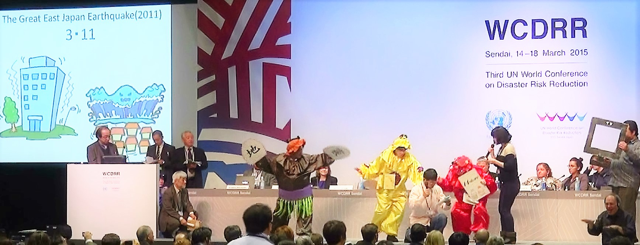

International Forum on DiDRR:

Implementing the Sendai Framework for Disaster Risk Reduction
13:00-16:15, 8th April 2016
Conference Hall, The Nippon Foundation, Tokyo, Japan

Co-organized by

The Nippon Foundation (TNF), Rehabilitation International (RI)

and Assistive Technology Development Organization (ATDO)

Live streaming video with English Caption available at:
http://www.ustream.tv/channel/zXb8GRGZcSe

Program
12:00-13:00 Registration
13:00-13:05 Welcome by Yasunobu Ishii, The Nippon Foundation
13:05-13:10 Welcome by Joseph Kwan, Rehabilitation International
13:10-13:30 Keynote: Disability inclusion as a continuum from DRR to emergency response
by Mathieu Simard, RI DiDRR Task Force Chair
13:30-15:00 Status of Sendai Framework from around the world
Moderators: Aqeel Quresi, GAATES/Techbility & Hiroshi Kawamura, ATDO
Presentation 1. From Sendai to Quito by Akiko Ito, Chief, SCRPD/DSPD/DESA/United Nations
Presentation 2. Implementation of the Incheon Strategy Goal 7 by Aiko Akiyama, UNESCAP
Presentation 3. Regional development of DiDRR in Latin America towards HABITAT III
by Fernando Jácome G., Technical Secretary for the Inclusive Management on Disabilities (SETEDIS), Vicepresidency of the Republic of Ecuador
Presentation 4. Cyclone Winston and Regional Development of DiDRR in the South Pacific
by Tomoko (Takeda) Minowa, Associate Programme Officer, Sub-Regional Office for the Pacific, UNISDR
Online contributions on Disability Inclusion Good Practices after Sendai :
Vietnam: Thu Huong Dao, Germany: Steffen Helbing
Questions and Answers
<15:00-15:15 Break>
15:15-16:10 Panel discussion on next steps to promote disability inclusion in DRR / DRM
and sustainable development (including online participation)
Moderators: Hiroshi Kawamura & Aqeel Quresi,
Briefing on IPTV accessibility standards development of ITU by Masahito Kawamori, ITU SG16
Briefing on the Situation of DiDRR in Arab Region by Khaled El Mohtar, National Rehabilitation and Development Centre, Lebanon
Panelists: Joseph Kwan, Masahito Kawamori, Khaled El Mohtar, and Mathieu Simard
16:10-16:15 Closing

Objectives of the Forum:
1. Identifying outcome of the joint initiatives to promote Disability-inclusive Disaster Risk Reduction launched by the Asia-Pacific Meeting on Disability-inclusive Disaster Risk Reduction: Changing Mindsets through Knowledge, 22-23 April 2014, Sendai, Japan
2. Sharing good practices in policy development and actual implementation of DiDRR in the context of implementation of the Convention on the Rights of Persons with Disabilities, The Sendai Framework for Disaster Risk Reduction 2015-2030, and the Sustainable Development Goals.
3. Specify next steps leading up to the HABITAT III in Quito and beyond.
4. Moving forward to make the most of technology development to promote participation of persons with disabilities

Logistics
All participants including speakers are to be self-funded
Meeting language is English
Registration is free of charge
English caption and Streaming Video Service will be available
Remote participation is encouraged

Registration
Pre-registration for contributions is closed. However, everybody is most welcome to observe the Forum via Internet:
http://www.ustream.tv/channel/zXb8GRGZcSe

The organizer decided to extend the registration deadline until 14:00 pm 7th April Tokyo time for both online and on-site participation. On-site participants require registration received by the deadline to clear security process. For on-line participants, registration in time will enable you to send questions and comments to moderators. In addition, those who have registered will receive follow-up information.

